**Problem: 4 Multi-city Hotel Chain Management System**

Design an Entity-Relationship schema for a multi-city hotel chain management system. The database must maintain hotels identified by hotel code, name, city, manager, number of rooms, and star rating. Rooms have room number, type, price per night, availability status, and belong to a hotel.

Guests have guest ID, name, loyalty level, booking history, and feedback given for bookings. Bookings have booking ID, guest, room, check-in and check-out dates, and total bill. Employees have employee ID, name, role, hotel assigned, and shift details.

Each hotel has multiple rooms and employees, and is managed by a manager who is also an employee. Guests can book rooms in any hotel and can have multiple active or past bookings. Rooms can be booked by different guests over time, but only one guest can occupy a room at a given time.

Employees are assigned to a specific hotel and can work in different shifts and roles. Loyalty level of a guest is updated based on their booking history and feedback. Feedback is linked to specific bookings and can influence loyalty level updates.

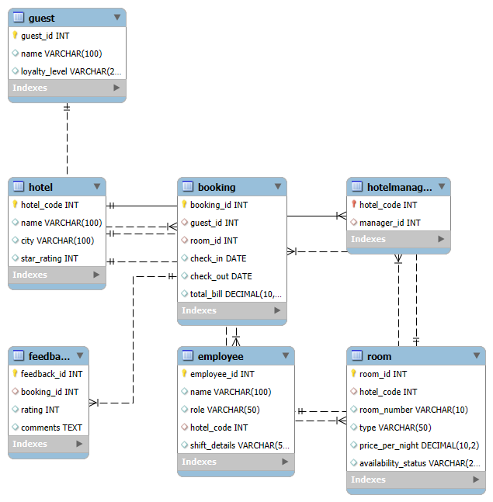

**-- Hotel table**

CREATE TABLE Hotel (

hotel_code INT PRIMARY KEY,

name VARCHAR(100),

city VARCHAR(100),

star_rating INT

);

**-- Room table**

CREATE TABLE Room (

room_id INT PRIMARY KEY AUTO_INCREMENT,

hotel_code INT,

room_number VARCHAR(10),

type VARCHAR(50),

price_per_night DECIMAL(10,2),

availability_status VARCHAR(20),

FOREIGN KEY (hotel_code) REFERENCES Hotel(hotel_code)

);

**-- Guest table**

CREATE TABLE Guest (

guest_id INT PRIMARY KEY AUTO_INCREMENT,

name VARCHAR(100),

loyalty_level VARCHAR(20)

);

**-- Booking table**

CREATE TABLE Booking (

booking_id INT PRIMARY KEY AUTO_INCREMENT,

guest_id INT,

room_id INT,

check_in DATE,

check_out DATE,

total_bill DECIMAL(10,2),

FOREIGN KEY (guest_id) REFERENCES Guest(guest_id),

FOREIGN KEY (room_id) REFERENCES Room(room_id)

);

**-- Feedback table**

CREATE TABLE Feedback (

feedback_id INT PRIMARY KEY AUTO_INCREMENT,

booking_id INT,

rating INT CHECK (rating BETWEEN 1 AND 5),

comments TEXT,

FOREIGN KEY (booking_id) REFERENCES Booking(booking_id)

);

**-- Employee table**

CREATE TABLE Employee (

employee_id INT PRIMARY KEY AUTO_INCREMENT,

name VARCHAR(100),

role VARCHAR(50),

hotel_code INT,

shift_details VARCHAR(50),

FOREIGN KEY (hotel_code) REFERENCES Hotel(hotel_code)

);

**-- Manager Assignment (1 manager per hotel, and manager is an employee)**

CREATE TABLE HotelManager (

hotel_code INT PRIMARY KEY,

manager_id INT,

FOREIGN KEY (hotel_code) REFERENCES Hotel(hotel_code),

FOREIGN KEY (manager_id) REFERENCES Employee(employee_id)

);